RECRUITING ASSISTANT FOR HR MANAGER

1.INTRODUCTION

1.1 OVERVIEW

A Human resources (HR) Assistant is a professional who is responsible for the daily Administrative and HR duties of an organisation . They assist with recruitment and record maintenance for payroll processing as well as proved clerical support to all employees.

1.2. PURPOSE

* The Goal of recruitment is to create a wide pool of qualified candidates from with one has to choose the most qualified individual for the job.
* It focuses on minimizing total costs and time spent on finding suitable employees.
* Recruitment is a well- organized and methodical approach in which a large number of people are given a detail description of a job opening.
* Improves the credibility of the organisation.
* Prevents disruption of business Activities.

2. PROBLEM DEFINITION AND DESIGN THINKING

2.1. EMPATHY MAP

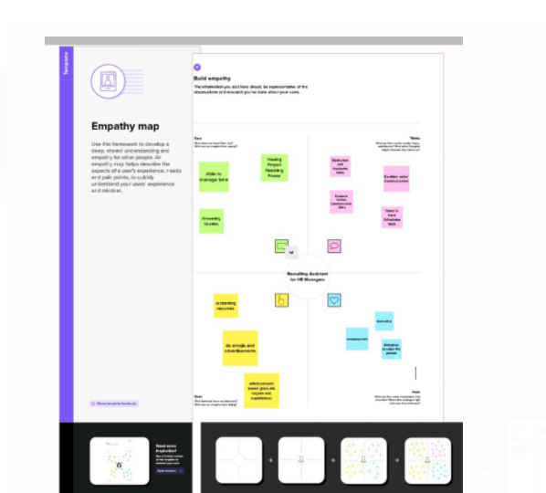

2.2. IDEATION AND BRAINSTORMING MAP

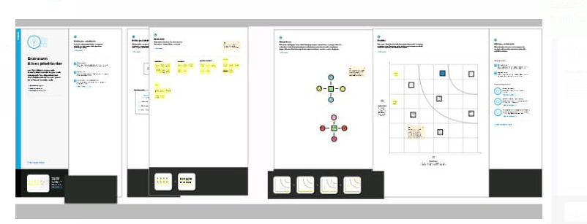

3.RESULT

3.1. DATA MODEL:

|  |  |
| --- | --- |
| Object Name | Field in the object |
| Custom | |  |  | | --- | --- | | Field label | Data type | | Job posting sites | Text | | Review | Auto number | |
| Custom junction | |  |  | | --- | --- | | Field Label | Date type | | Job posting | Auto number | |

3.2 .ACTIVITY & SCREENSHOT

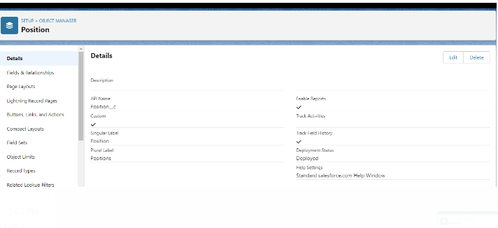

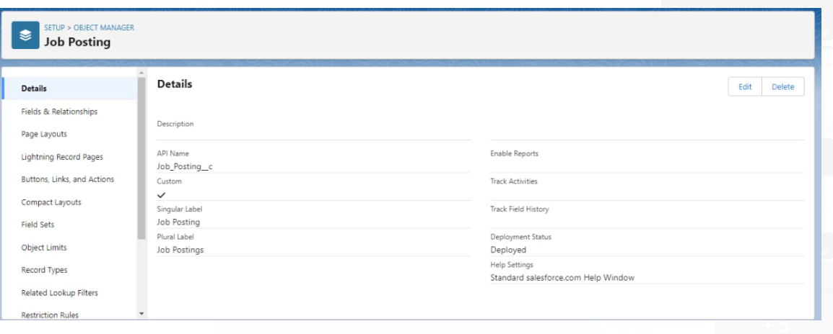

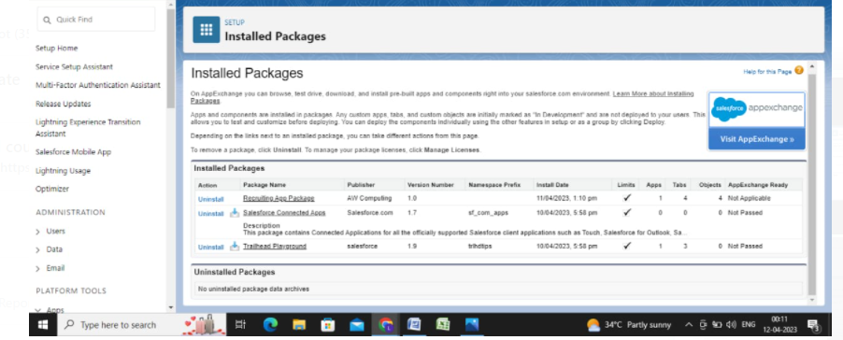

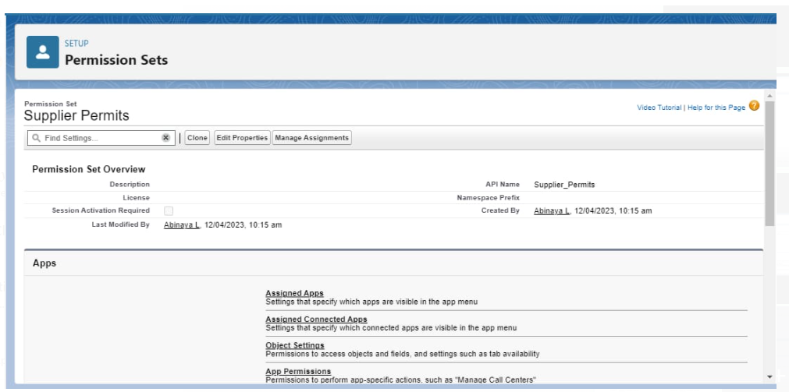

4. TRAILHEAD PROFILE PUBLIC URL

TEAM LEADER - <https://trailblazer.me/id/logas11>

TEAM MEMBER 1 - <https://trailblazer.me/id/anusp18>

TEAM MEMBER 2- <https://trailblazer.me/id/dhanm27>

TEAM MEMBER 3 - <https://trailblazer.me/id/keerv17>

TEAM MEMBER 4 <https://trailblazer.me/id/bbhubaneshwari>

PROJECT REPORT TEMPLATE

5. ADVANTAGES AND DISADVANTAGES

ADVANTAGES

* Generates information valuable for policy and decision making .
* Precise estimates of performance .
* Access a large talent pool .
* Build a business as diverse as your clients.
* Make the most of management experience.

DISADVANTAGES

* It costs money to work with a recruiting agency.
* Lack of communication.
* Different bias.
* Less of understanding when it comes to the environment of the company.
* Another gap to fill.

6. APPLICATIONS

* Responsible for the daily Administrative and HR duties of an organization .
* Record maintenance for payroll processing.
* They assist with recruitment.

7. Conclusion

Human resource development is a means an end . That end is usually acknowledged to be getting better results from the Organization , teams and individuals by understanding and managing performance within an agreed framework of planned goals ,objectives and standards .

8. FUTURE SCOPE

The role of HR is continuously evolving and HR professionals can aim to learn about the technologies and trends and operational changes shaping the future of business .

HR can be agile adapting to these changes in order to effectively support employee Development , retention and recruitment.

The next step for an HR Director is the role of the CHRO. This is the HR and Cultural leader .